**Squander**

**Waste Management Application**

**USER MANUAL**

**Contents:**

**1. Getting Started.……………………. 3**

**2. Home Screen………………………. 4**

**3. Capturing or Selecting images… 5**

3.1. Capture Image via camera …….………… **6**

3.2. Selecting From Photo Library …….………. **8**

**4. Image Processing…………… 9**

**5. Results Screen………………… 10**

**Getting Started:**

Welcome to the official user guide of Squander, an image-based waste classification application.

Before we begin, please ensure that we download the app from the Apple App Store by searching the app name “SQUANDER”.

After we download the app, follow this guide for instructions on how to recycle an item and plan for its proper disposal.

**Home Screen:**

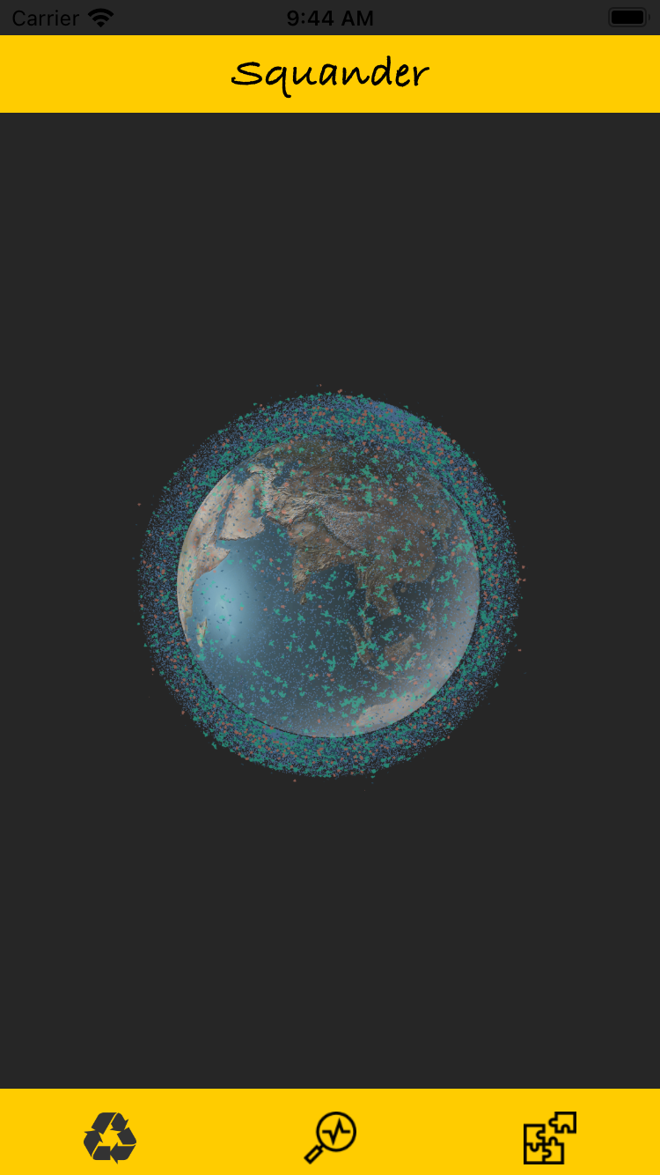

To know if a product can be recycled simply click on “Earth Image” in the center of the screen. This will prompt an alert so that you can select options to capture the image.

**Capturing or Selecting Image:**

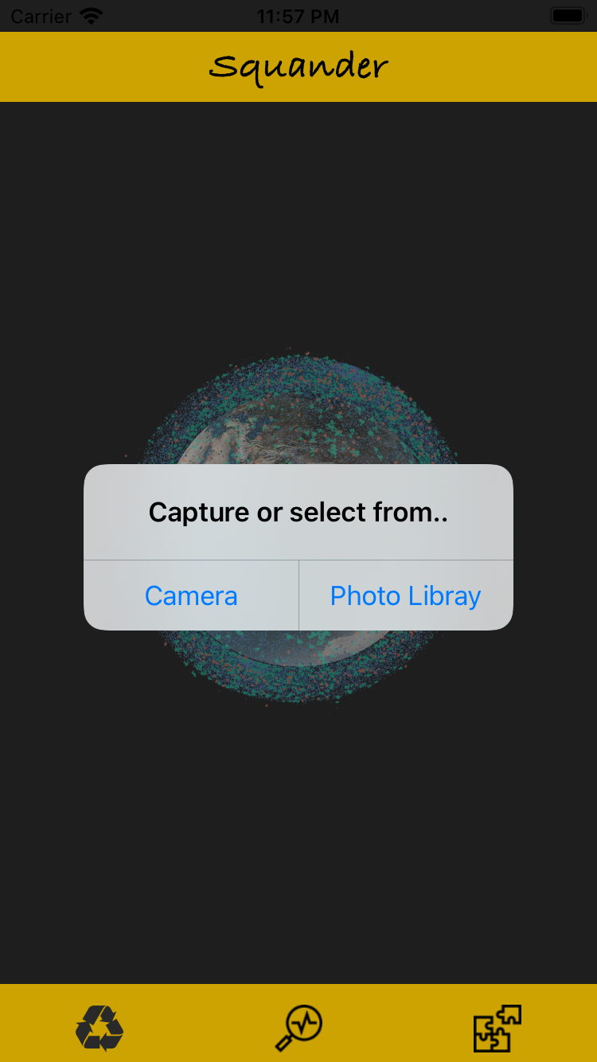Once clicked on “Earth Image” an alert is displayed giving two options:

1. Capture Image via camera

2. Select the Image from the photo library.

Once clicked it will navigate you to the capture screen or

photo library as per your action.

***If you want to dismiss this alert click outside of the alert...***

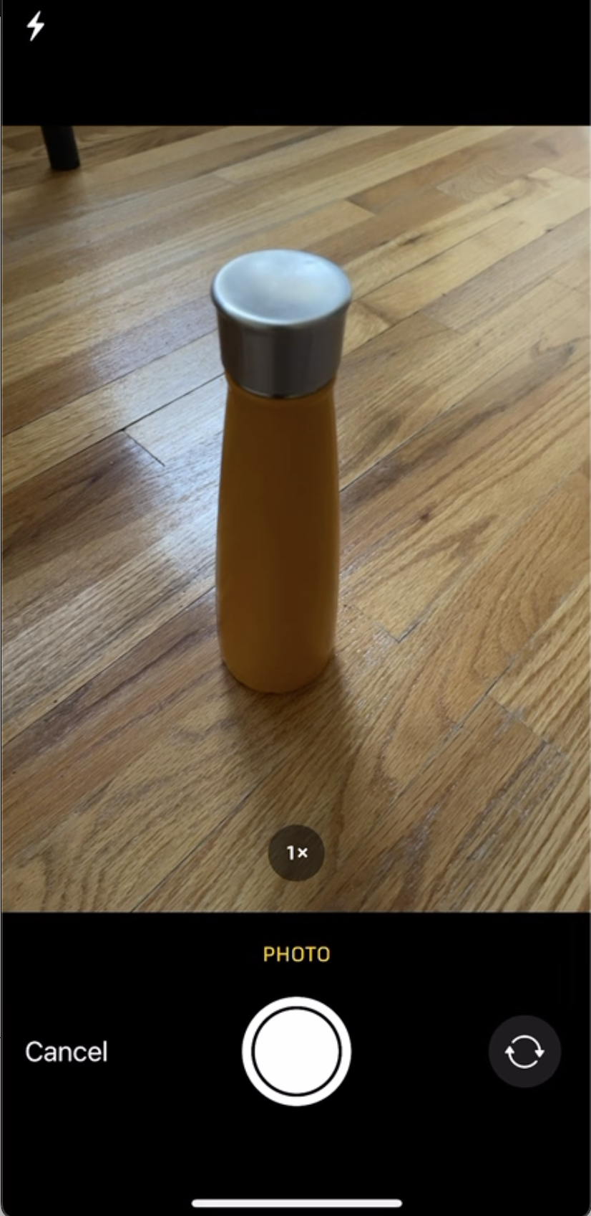**1. Capturing Image via Camera:**

Selecting the option camera from the alert will navigate to the camera capture screen. Where they can click the capture button in the bottom center to Capture the image.

***Clicking on cancel will navigate to Home Screen***

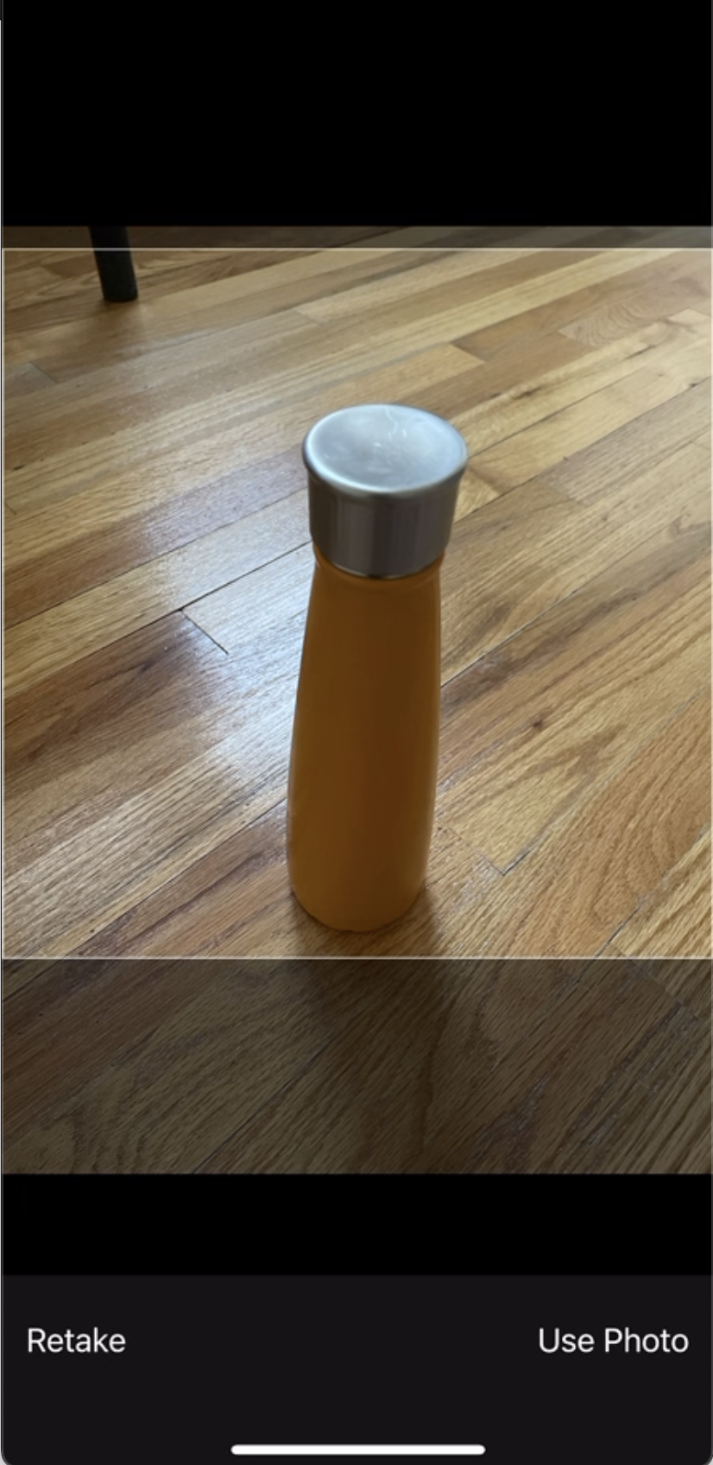After capturing the photo, at the bottom bar, two options will be provided

Whether to “Retake” or “Use photo”.

Once clicked on “Use Photo”

The image will be uploaded to a machine learning algorithm for the classification of recyclable waste from the image and you are navigated to the Processing screen.

***Clicking on retake will navigate to capture Screen***

**2. Selecting from Photo Library:**

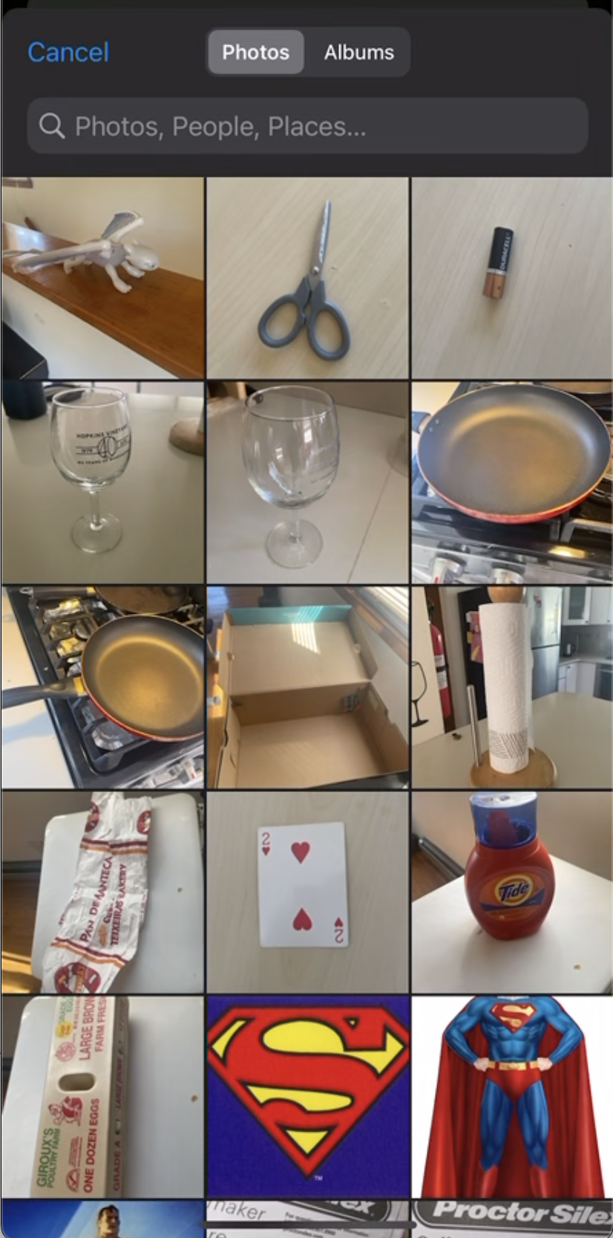

If you select the option “Photo Library” from the alert, then you are navigated to a photo gallery where you can select images that are already captured and after which the image will be uploaded to a machine-learning algorithm for the classification of recyclable waste from the image and you are navigated to Processing screen.

**Image Processing:**

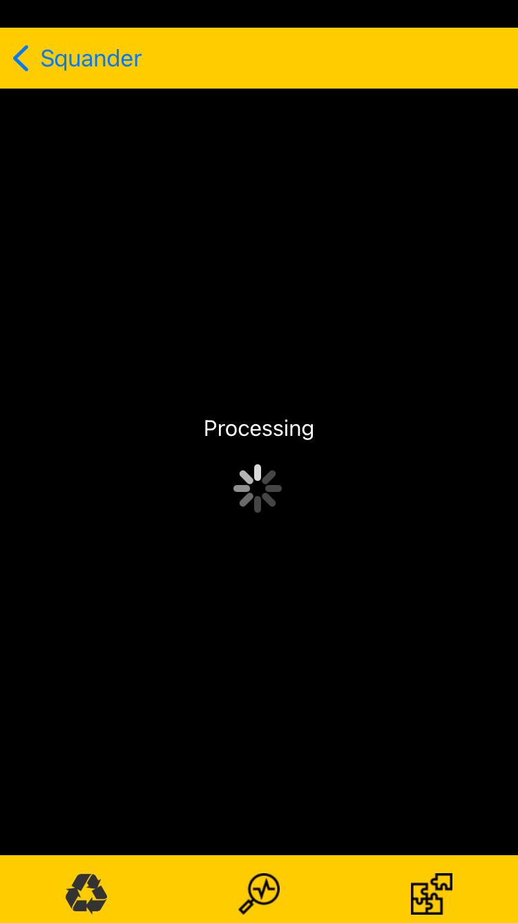

Once the image is captured or selected you will be navigated to the processing screen where the uploaded image is processed by

Machine Learning algorithm.

***If you want to navigate back to the home screen, click on the arrow at the top left corner***

**Getting Results:**

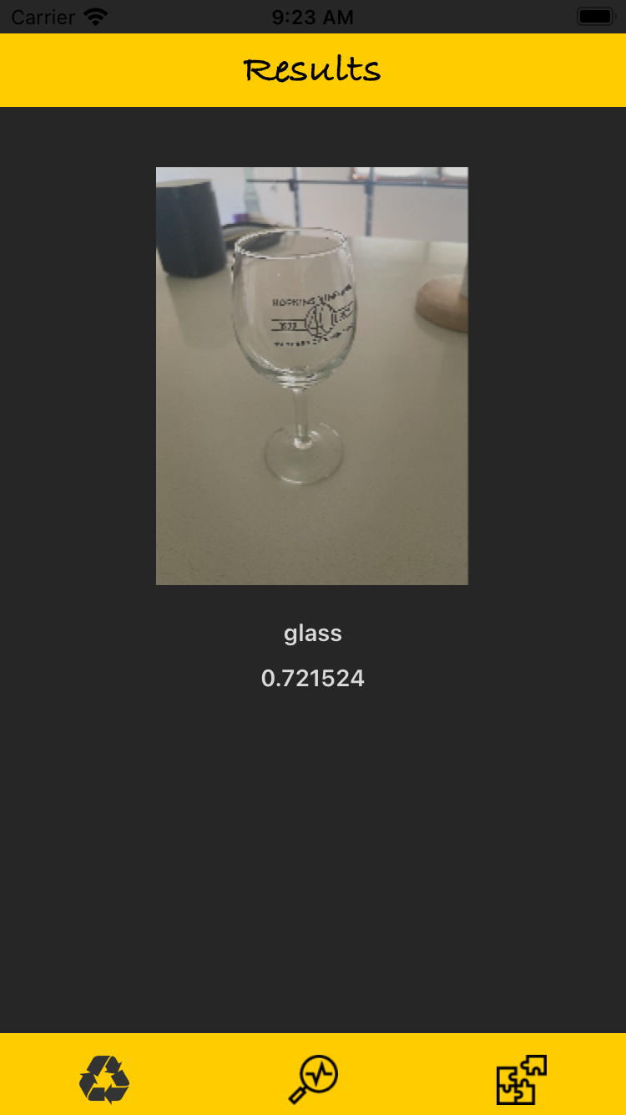

Now after processing the image by machine learning algorithm results screen is displayed giving information about recyclable items found in the image and their confidence value.